Java Interview Questions:
- Java - High level, Object oriented, Platform independent, multi-threaded language able to write applications, web services a, nd mobile applications.
Restrictions – goto statement, Multiple inheritance, operator overloading, call by reference
Object class is the root of inheritance.
- JDK – Software development environment used to develop the applets and applications. SE, EE, ME. Combination of JRE and JVM
- JRE – Implementation of JVM. Runtime Environment to run the java programs. Contains set of libraries that JVM uses on run time.
- JVM – Enables computer to run a program. Runtime engine call the main method. Compiles java code to byte code to machine independent. Kick start the main method of the java program
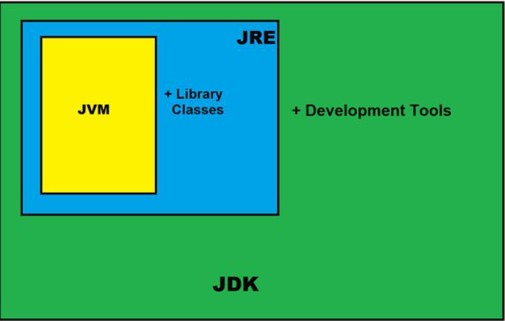
- JVM Architecture
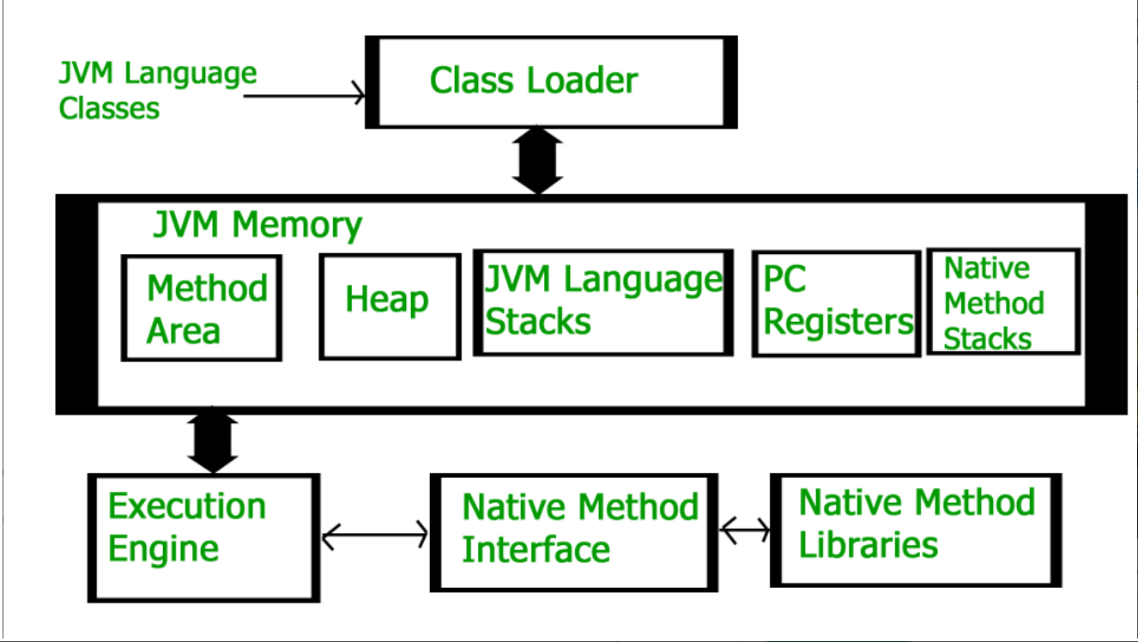
- Class Loader Subsystem:
Loading –Reads .class file and generate binary data for class and store in Method Area
Linking – Links the .class file with immediate parent/interface/Enum
Initialization – Initialize all the methods.
- Memories in JVM: Class AREA- store class structure to runtime constant pool, field, method data.
Heap – Runtime memory is allocated to objects.
Stack – Frames, local variable memory partially, created when method invoke and destroy when it’s done.
Program Counter register: Contains address of JVM currently executed.
Native Method Stack: uses native method to store memory.
- Class Loader – The programmer is first loaded by the class loader once its executed.
Bootstrap – It loads $JAVA_HOME/jre/lib and rt.jar file contains the SE edition like util,sql,.net package.
Extension – It loads the jar files inside $JAVA_HOME/jre/lib/ext directory.
System/Application : It loads files form Class path which we specified.
- JIT Compiler: Compiles the same type byte code and increases the performances and reduces the time of compilation.
- Plat form – Hardware to execute the codes. Software based platform. Hardware based platform.
- Java - Software based platform, Other Languages - Hardware based platform.
- Write once and run anywhere – Compiler converts java program to byte code so its platform/machine independent.
- Empty File can be executed in java.
- If you not pass any value in cmd line argument then string will assume as Empty and not null.
- Order of specifiers is not a problem in java.
- Access Modifiers in Java: Accessibility or scope of the field, method, class and constructor.
Public – Access to any class or method
Protected – Access to classes/subclass in same package
Private – Access with in class only
Default – Access with in the package
- Static - Shared amongst class and not object. And common to all the object in the class.
- Object – Real world Entity with state and behaviour. Instance of the class.
- Object Oriented Language – Use all the oops concept like polymorphism – C++
Object based Language – Does not Use all the oops concept like polymorphism – JS, VBscript
- Initial state of object is null and new is the keyword to create.
- Constructor – Special type of object used to initialize the state of object.
Default – Does not accept any value, Used to initialize the instance with default values.
Parameterized – Accept arguments, Used to initialize the instance with given values.
- Default – implicitly invoked, Parameterized - explicitly invoked.
- Default Constructor is automatically created if no constructor is defined in class.
- No Return type is there for Constructor, it will return instance of the class.
- Constructor Cannot be inherited
- Constructor Cannot be made final
- Constructor can be overloaded.
- Copy Constructor – copy value to another constructor is possible
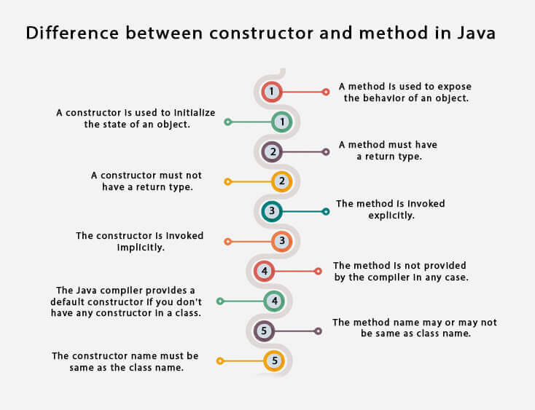
- Static – Common property to all the objects in the class. Memory allocated only once in the class area at the time of class loading. So, its memory efficient
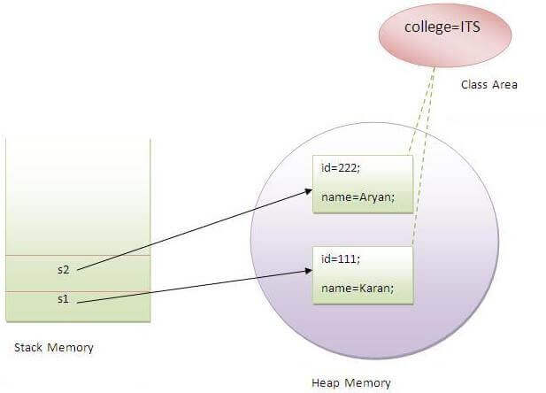
- Static Method – Belong to class not object, no instance is required, Static method can access and change the static variable.
this, super, cannot be used. Non static member cannot be called directly.
- Main method is made static as no need to create object. If we use not static method JVM need to create object so memory allocation is needed.
- Static method cannot be overridden and only hidden
- Method Hiding: Subclass defines a static method with the same signature as a static method in the super class.
Method resolution is taken care by Compiler based on reference object.
- Without main class we can execute the program. Using static block. Before 1.7 JDK
- No Such Method error will be thrown if we remove the static modifier in main method.
- Constructor Static – Will result in error, constructor is invoked once the object instance is created so no use of static in constructor.
- Abstract method – Will become the part of class and called directly so unnecessary call of unimplemented method can be avoided
- this keyword – current object reference, can be sent as arguments to constructor/method call, invoke current class method, return class instance from method.
- this keyword cannot be assigned to a variable
- can be used for static variable also but not a good practice
- Constructor chaining – call one constructor by another constructor.
- Oops Concepts – Object, Class, Inheritance, Encapsulation, Abstraction, Polymorphism.
- Abstraction : Abstraction is a process of hiding the implementation details and showing only functionality to the user
- Inheritance – Process of one object acquiring all the properties and behaviour of another object from another class. Reusable code IS-A relationship. Single, Multiple, Multilevel, hybrid, hierarchal.
- Inheritance uses – reusable code, to achieve runtime polymorphism, data hiding to the child class. To achieve method overriding.
- Object class is the super class of all classes in java.
- Multiple Inheritance – To reduce the complexity/ambiguity while inheriting the parent class has same methods.
- Aggregation – Relationship between the classes when aggregate class contains a reference of the class it owns. HAS-A relationship.
- Composition - Relationship between the classes when aggregate class contains a reference of the class it owns and cannot exist without the container object
- Aggregation – Weak relationship, Composition – Stronger relationship
- Pointer is a variable that holds the address. It makes complex so not used in java
- Used to refer the immediate parent object. Implicitly calls the parent. The super() is called in the class constructor implicitly by the compiler if there is no super or this.
- Uses of super() – refer invoke the immediate parent class variable/method/constructor
- Super – points to class context, used for initializing the base class variable to derived class variable and should be the first statement or will throw error. this keyword - points to current class context. And used to differentiate the local and instance variable in the constructor. Cannot use both in constructor.
- Overloading – Polymorphism technique in which the same method name is used for more than one method with different signature (changing no of arguments/data types).
- Can over load main method.
- Type Promotion:
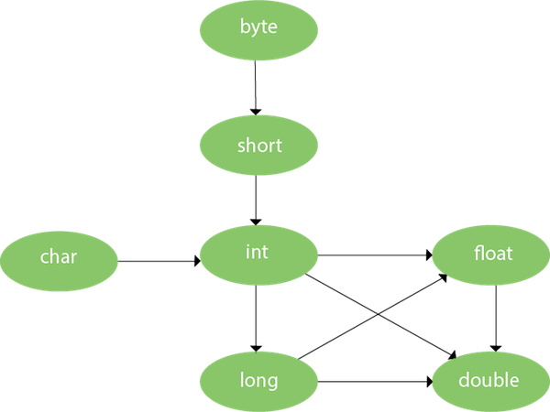
- Overriding - Subclass provides implementation of the same method present in parent class is called over riding. Used to achieve run time polymorphism.
Method name should be same as parent class method name, should be inherited class IS-A relationship, same signature as parent class.
Method resolution is taken care by jvm in run time with respect to runtime object
- Static methods cannot be override, static method is part of the class instance method is bound with object so gets memory in heap so not necessary to override. No runtime polymorphism is achieved.
- Private methods cannot be overridden, as scope is limited and cannot be accessed outside the class.
- Changing the scope of overridden methods: The private can be changed to protected, public, or default, The protected can be changed to public or default. The default can be changed to public. The public will always remain public.
- Final – restrict it from user updating, once assigned it cannot be changed, Stop inheritance, overriding, value change.
- Final method – cannot be over ridden
- Final class - cannot be inherited
- Final Blank variable – not initialized at the time of the declaration, cannot initialize directly and will be done only by constructor.
- Static Final block can be initialized by static block. If non static initialize can be done by constructor.
- Main method can be declared as final
- Constructor and Interface/Abstract cannot be declared as final as it need to implemented.
- Garbage Collection: Used to destroy the unused memory in runtime.
Null, referring to another reference, anonymous object.
- Finalize: method invoked before the garbage collected, perform clean up processing.
- GC Algorithm: mark and sweep
Mark Phase: Find the unreachable object (set false) if reachable set (true)
Sweep Phase: Sweeps the unreachable object.
- Encapsulation: It is the process of bind the data and object in single unit. It is used to data hiding. It can be achieved by Private members.
- Polymorphism : Polymorphism in Java is the ability of an object to take many forms
- With null reference we can call static method.
- Immutable in Java: Cannot be changed once it’s the obj is created. Wrapper class like int, Boolean, long and short.
Class is set as final, Data members are private/final cannot be accessed, Deep copy – creates an actual copy of the obj and returns only copy. Will not affect the original variable.
- Multithreading: It is process of running the multiple threads in same time. The process have the multiple threads to be runs at same time to achieve performance.
- Synchronized: to avoid the multiple threads use the same obj in same time. Which will give multiple errors.
- Exception Handing: Unwanted errors or event that cause abnormal stop of the application/ affect the flow
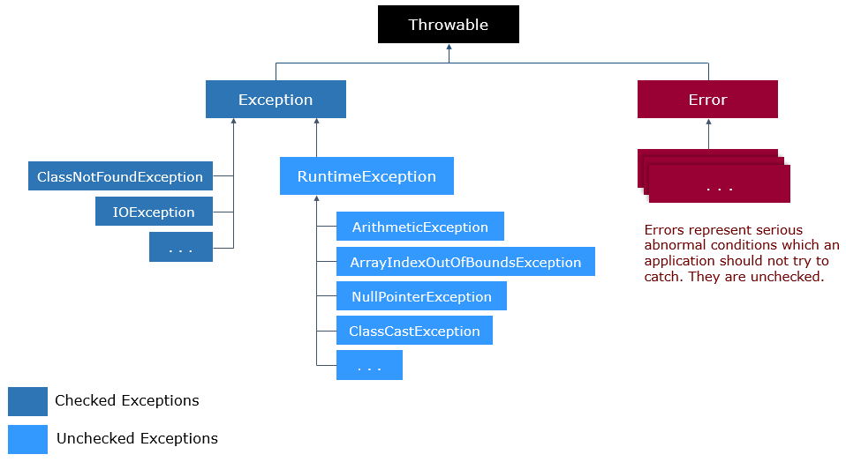
- Compile Time – Error , Runtime – Exception
- Throw – explicitly throw an exception(Manually), throws – to inform the method will throw an exception(May or may not throw)
- Try catch block is used to handle exceptions.
- Checked exceptions – compile time Unchecked exceptions – runtime
- We can use try block without any catch block. Finally should be there.
- System. Exit will exit the finally block without executing
- Try with resources should be closed after the usage (Scanner, DB connection) it can be multiple objects
- 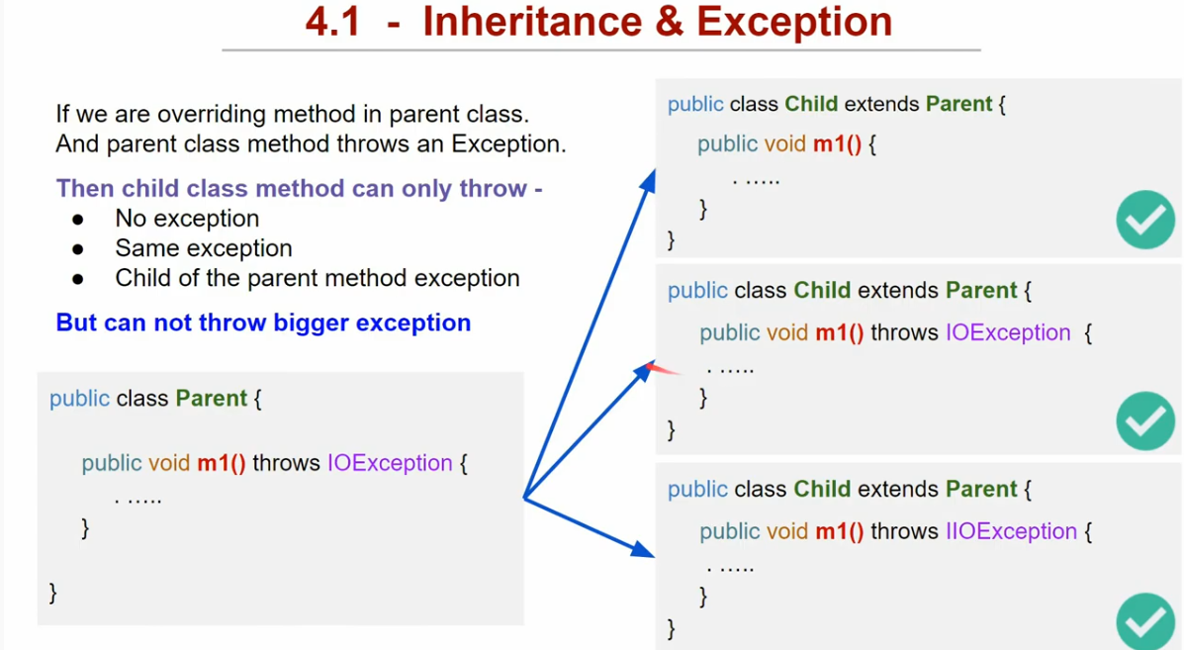
- Custom Checked
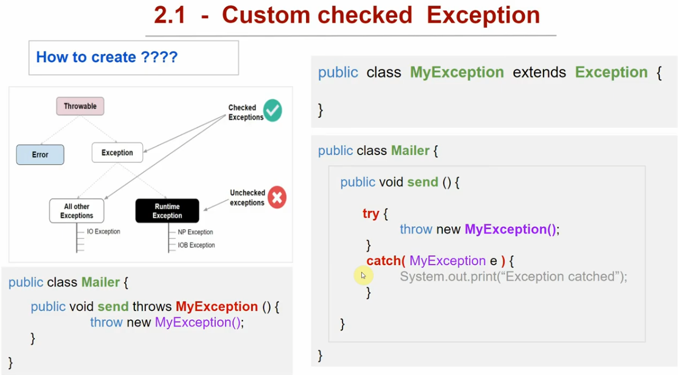
- Custom Unchecked
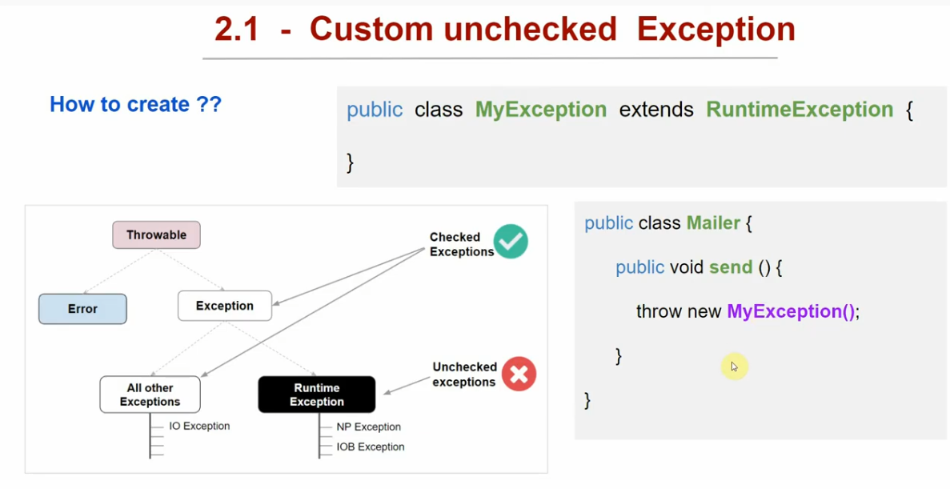
- Method Hiding: sub class defines a static method with same signature in super class, method in subclass hides the method in base class
- Sleep: Pause the execution of the thread for the defined time in milliseconds.
- Wait: It will stop or wait the execution until it’s called by notify or notifyAll.
- Notify: Sends notification to the singe thread that waits among the thread waiting for the lock.
- NotifyAll: Sends notification to the all thread that waits among the thread waiting for the lock.
- Collections: Iterable – Root Interface
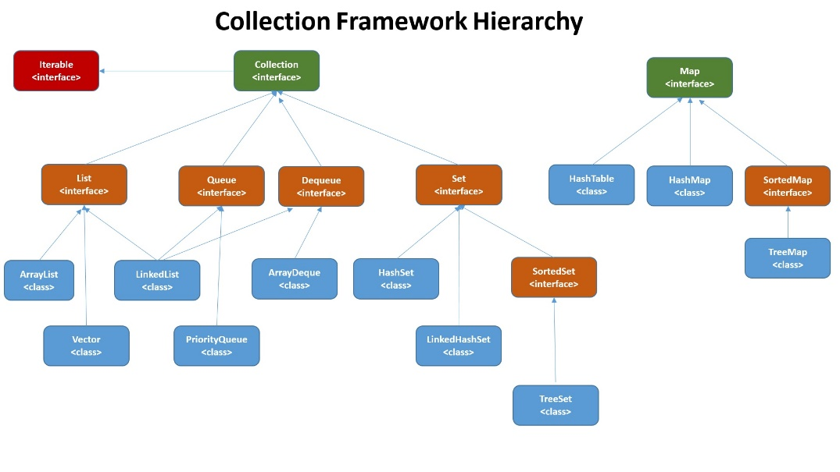

Collection Type | Collection Subtype | Storage type | Duplicates | Synchronized | Insertion order | Access object
List | ArrayList | Dynamic array size | Yes and Null | Non Synchronized | Yes | Slow – random access
 | Linkedlist | Doubly linked list | Yes | Non Synchronized | Yes | Fast
 | Vector | Dynamic array size | Yes | Synchronized
 | Stack | LIFO | Yes | Synchronized
Queue | Queue | FIFO – Ordered List | Yes
 | Priority Queue | Processed by priorty |  |  |  | Can have null objects
Dequeue | Dequeue | Doubly ended queue – Both side insertion and deletion
 | Array Dequeue | Same as Dequeue |  |  |  | Only one null value
Set | Set | unordered way | No
 | Hashset | Hash Map to store | No and Null values are allowed
 | Linkedhash Set | Linked list | No |  | Yes | Yes
 | Sorted set | Order ASEC
 | Treeset | Fast access | No and Null values are not allowed
- == -> Reference Comparison(When two object have same reference returns true),
.equals() -> Content Comparison(Wrapper class has overridden equal method)
- Hash Map Internal Working:
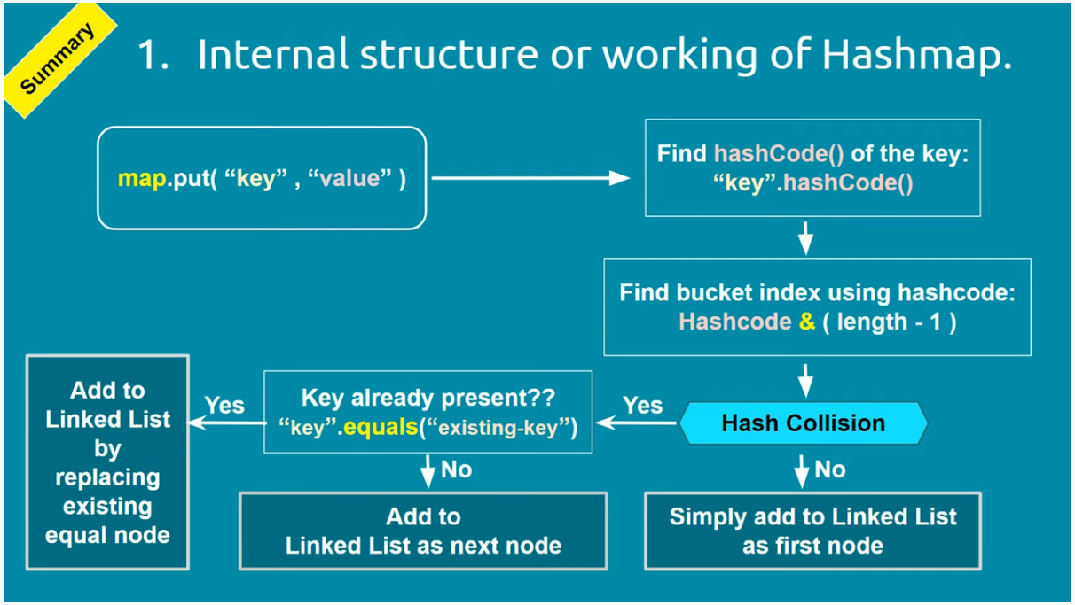
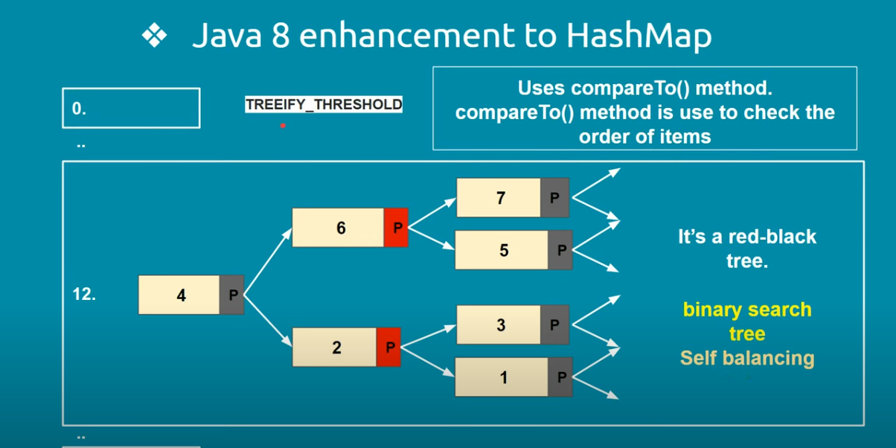
88) 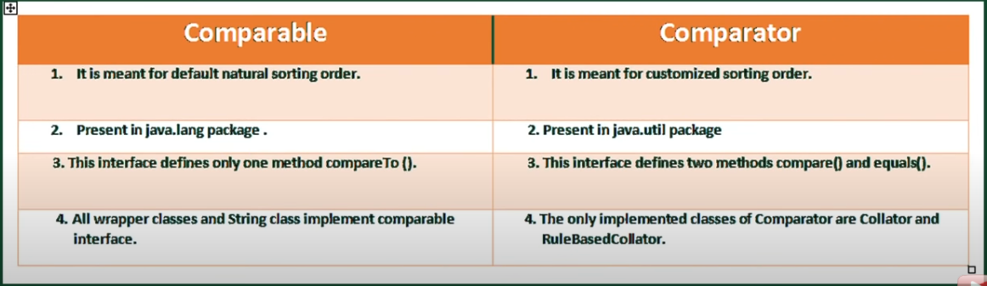
89) Interface and Abstract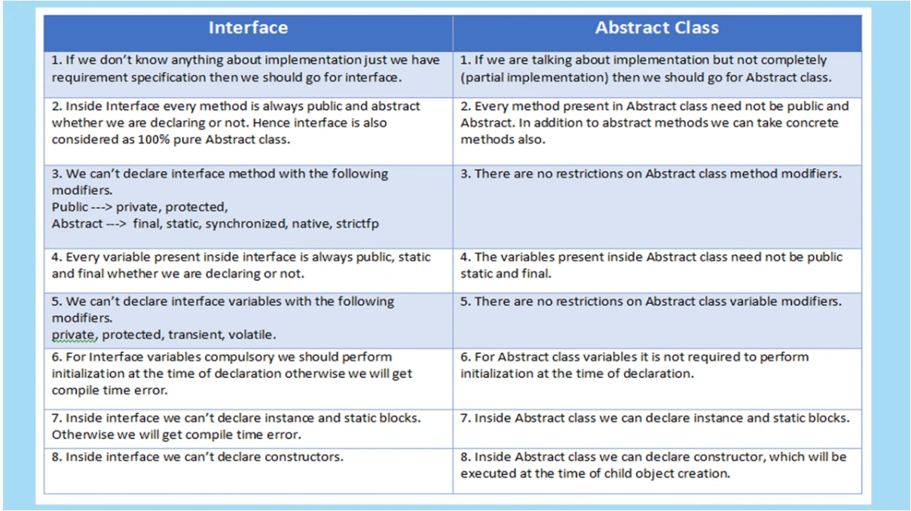
90) Array list Internal Working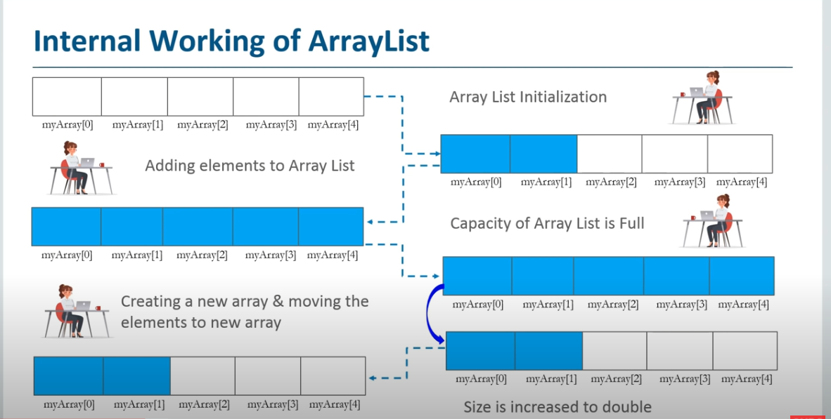

91) Spring Life cycle Bean: Bean life cycle is managed by the spring container. Container is used to create, initialize, wire and destroy the bean automatically with the configurations.
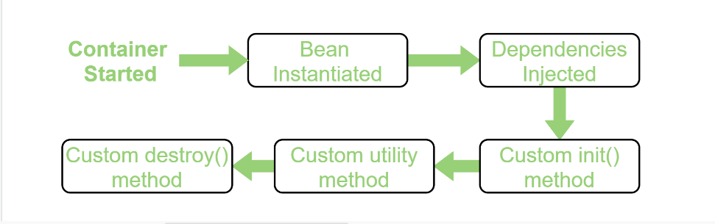
XML method, Java Programmatic method, Annotation method.
XML method | Java Programmatic method | Annotation method
Init() | Implements interface (InitializingBean,DisposableBean) , afterPropertiesSet() | @PostConstruct
Destroy () | Destroy() | @Predestroy
92) Upcasting – Casting a subclass to Superclass A a = new B(); Bis child class.
Down casting in inheritance. If theo Super class method don’t have the method that sub class have an we need to refer to super class reference down casting is needed. A a = new B();
B b = (B) a; -> Downcasting
93) Exception Types:
ArithmeticException
It is thrown when an exceptional condition has occurred in an arithmetic operation.
ArrayIndexOutOfBoundsException
It is thrown to indicate that an array has been accessed with an illegal index. The index is either negative or greater than or equal to the size of the array.
ClassNotFoundException
This Exception is raised when we try to access a class whose definition is not found
FileNotFoundException
This Exception is raised when a file is not accessible or does not open.
IOException
It is thrown when an input-output operation failed or interrupted
InterruptedException
It is thrown when a thread is waiting, sleeping, or doing some processing, and it is interrupted.
NoSuchFieldException
It is thrown when a class does not contain the field (or variable) specified
NoSuchMethodException
It is thrown when accessing a method which is not found.
NullPointerException
This exception is raised when referring to the members of a null object. Null represents nothing
NumberFormatException
This exception is raised when a method could not convert a string into a numeric format.
RuntimeException
This represents any exception which occurs during runtime.
StringIndexOutOfBoundsException
It is thrown by String class methods to indicate that an index is either negative or greater than the size of the string.
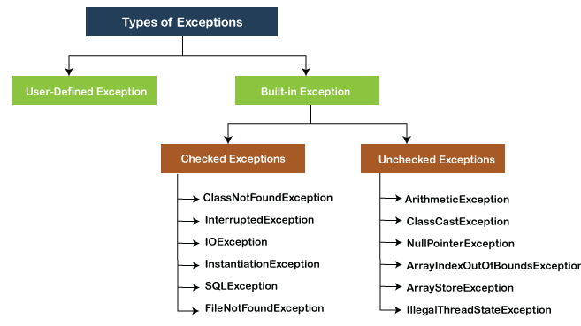

Try With Resourses
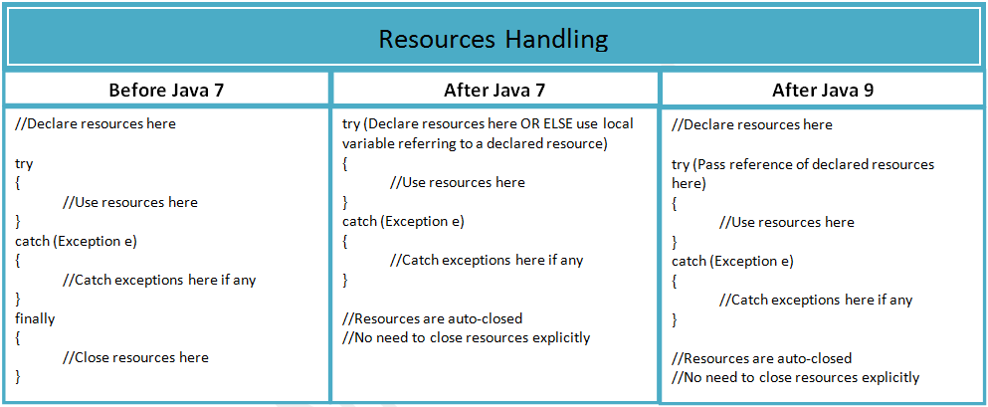
Out of Memory Error
java MyProgram -Xms1024m -Xmx1024m -XX:PermSize=64M -XX:MaxPermSize=256m

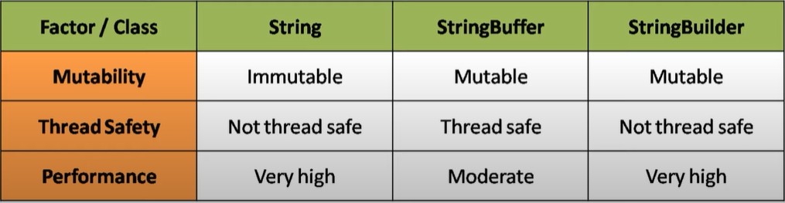
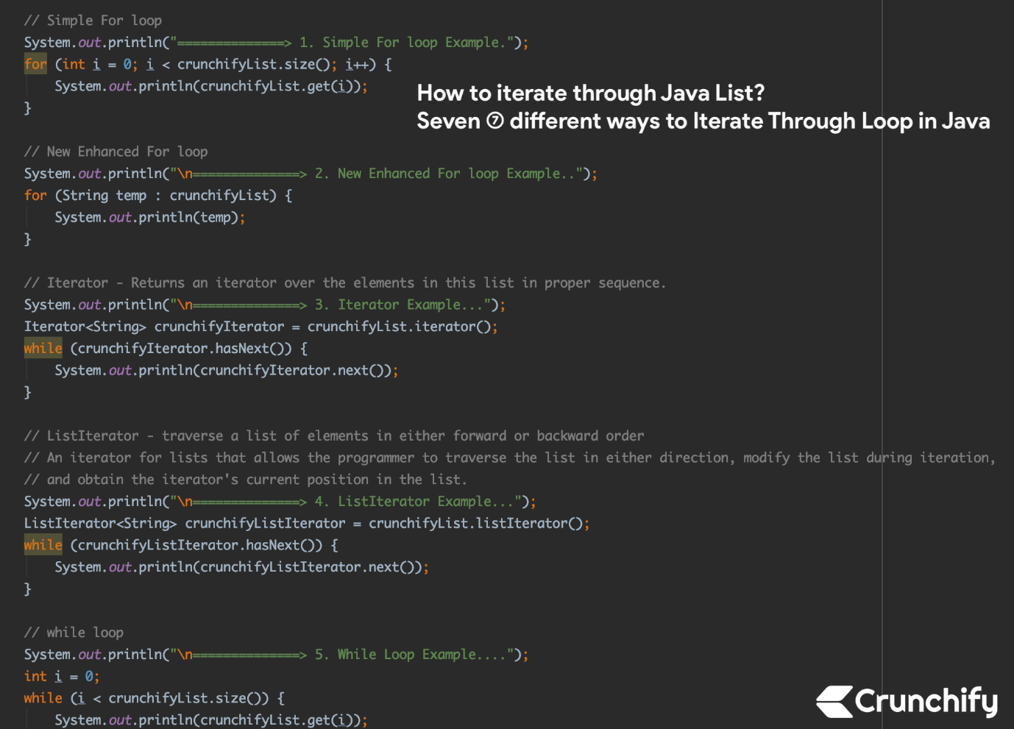

@Component vs @Bean
@Component auto detects and configures the beans using classpath scanning whereas @Bean explicitly declares a single bean, rather than letting Spring do it automatically.
@Component does not decouple the declaration of the bean from the class definition whereas @Bean decouples the declaration of the bean from the class definition.
@Component is a class level annotation whereas @Bean is a method level annotation and name of the method serves as the bean name.
@Component need not to be used with the @Configuration annotation whereas @Bean annotation has to be used within the class which is annotated with @Configuration.
We cannot create a bean of a class using @Component, if the class is outside spring container whereas we can create a bean of a class using @Bean even if the class is present outside the spring container.
@Component has different specializations like @Controller, @Repository and @Service whereas @Bean has no specializations.

